**Experiment 5**

**Student Name: Mohit Kumar UID: 20BCS9473**

**Branch: BE-CSE Section/Group: 20BCS-DM-714/A**

**Semester: 6 Subject Code: 20CSP-376**

**Subject Name: Data Mining Lab Date of Performance: 11-04-2023**

1. **Aim/Overview of the practical:** To perform the classification by decision tree induction.
2. **Tools used:** RStudio
3. **Code:**

library(RWeka)

library(partykit)

library(caTools)

setwd("C:\\Users\\hp\\Documents\\DATA MINING CODES\\EXPERIMENT 5")

getwd()

iris_data = iris

str(iris_data)

summary(iris_data)

spl = sample.split(iris_data, SplitRatio = 0.7)

dataTrain = subset(iris_data, spl==TRUE)

dataTest = subset(iris_data, spl==FALSE)

m1 <- J48(Species~., dataTrain)

summary(m1)

dataTestPred <- predict(m1, newdata = dataTest)

table_matrix <- table(dataTest$Species, dataTestPred)

print(table_matrix)

accuracy_Test <- sum(diag(table_matrix)) / sum(table_matrix)

cat("Test Accuracy is: ", accuracy_Test)

pdf("Iris_decision_plot.pdf", paper="a4")

plot(m1, type="simple")

dev.off()

1. **Output:**

RStudio:

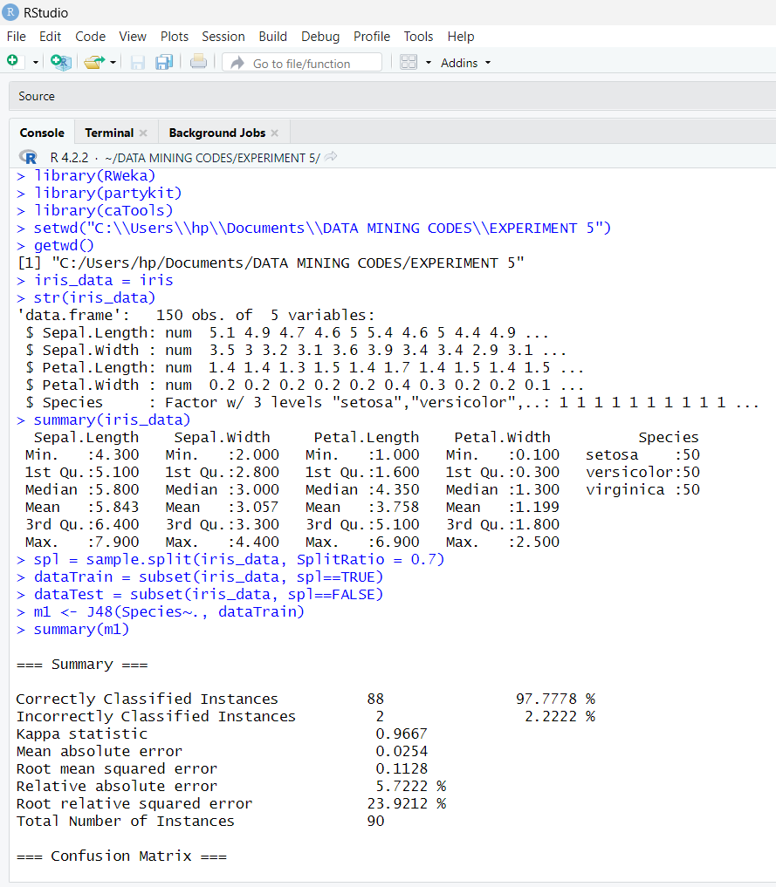

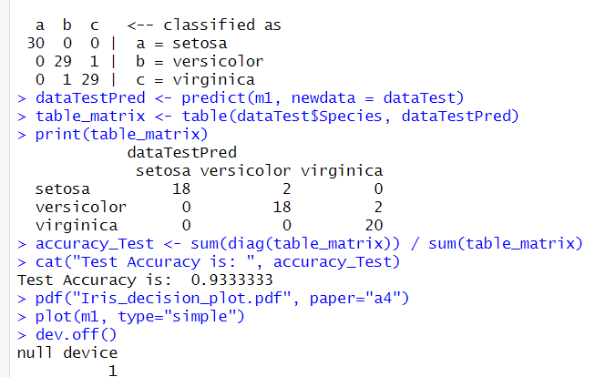

Iris_decision_plot file:

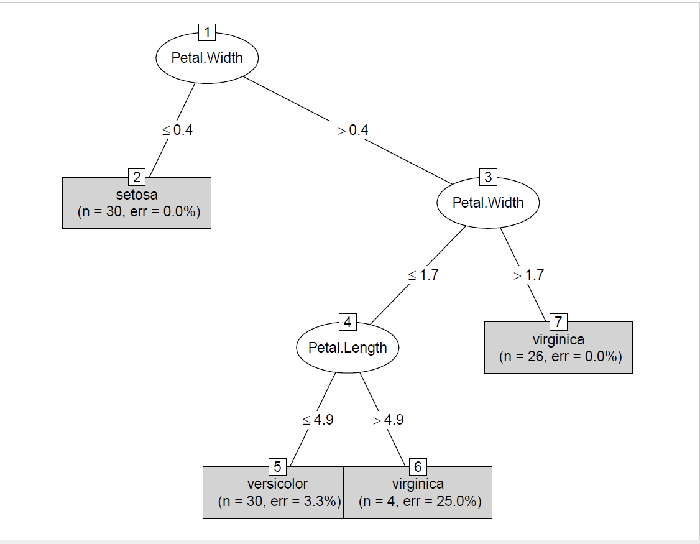

1. **Observation:**

* Learnt how to use R and create a file in Rstudio.
* Learnt how to load dataset iris in Rstudio.
* Learned How to Implement Decision Tree in R Studio.